International Championship of Czech republic in drytooling leed and competition in drytooling speed

BLACK DIAMOND Drytoolcup Brno 2011

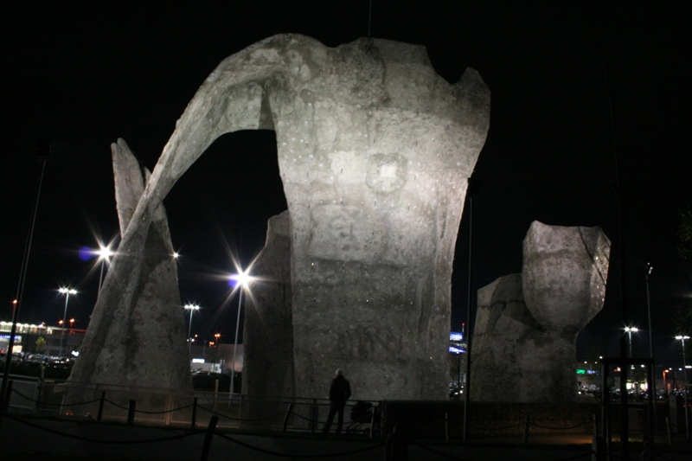

Promoters:

Czech Mountaineering asociation, Climbing Club Lokomotiva Brno, Climbing centre Klajda

Main partner of competition:

Black Diamond

Date of competition:
Saturday 10.12.2011

Place of competition:
Outdoor climbing wall Olympia
adress:
Olympia lezecká stěna
U Dálnice 777
664 42 Brno - Modřice
Czech republic

System of competition:
Drytooling leed will be two runs. Qulification and final. Qualification will be on five routes FLASH (women three routes) and after will be final run.
In mens final will be 8 competitors, in womens final will be 6 competitors.
Drytooling speed will be two according routes. The treining will be possible during qualification of leed, the final will be parralel run in elimination style.

Timeplan of competition:
8:00 – presence of competitors
9:00 – demonstration of qualification routes
9:20 – 14:30 – qualification leed
9:00 – 15:30 – training speed
15:30 – 17:00 – final speed
17:15 – 17:30 – prewiev final leed women
17:30 – 18:30 – final leed women
18:30 – 18:45 – prewiev final leed men
18:45 – 20:00 – final leed men
20:00 – ??? - announcement of results and awards ceremony, afterparty with slideshow of Marek Holecek about his himalayan alpine style ascents

Starting fee
For members CHS, OeAV , partners organization in UIAA and no organized competitors regisred till 1.12.2010 is 200,- CZK (8 EUR). Registration after 1.12.2010 is starting fee is 250,- CZK/10 EUR. It will be possible send to the banc account or pay cash during the presence of competitors.
The starting fee cover the present for each competitor and refreshment

Awards
Small present for each competitor

leed men
1. 200 EUR + present
2. 100 EUR + present
3. 50 EUR + present
leed women
1. 100 EUR + present
2. 50 EUR + present
3. 30 EUR + present

speed men and women
Presents for first three competitors in mens a womens cathegory.

Contact:
Horolezecký oddíl Lokomotiva Brno www.lokalka.eu
Mgr. Radek Lienerth – director of organization
Tel: +420603810600
e-mail: zoban@seznam.cz

